全文格式说明 (In Chinese)
1. 全文用A4 大小,字数5000-6000；Times New Roman字体，无页码；无页数要求；
2. 大标题：三号加粗，居中，24磅行距；
3. 作者：小四加粗，居中，段前15磅，段后15磅；
4. 摘要，关键词：五号，单行倍距，Abstract和 Keywords加粗；
5. 摘要后加入分页符；
6. 作者简介放入首页页脚，字体为小五，单行倍距；
7. 一级标题：四号加粗，段前0.5行，段后0.5行；
8. 二级标题：小四加粗，段前0.5行，段后0.5行。若与一级标题相连，则段前0行，段后 0.5 行；
9. 三级标题：五号加粗；
10. 正文：五号，单行倍距。首段左对齐，其他段前空四格；
11. 参考文献：五号，悬挂缩进2字符，段间距为固定值14磅；
12. 表格标题：小五加粗，左对齐，段前0.5行，段后0行；
13. 表格内字体：小五；
14. 表格后若是段落，则段前0.5行，左对齐；
15. 页边距：普通 上2.54厘米，下2.54厘米，左和右为3.18厘米。

Format of full paper (In English)
1. Use A4 page set-up, word number limit: 5000-6000, only Times New Roman font should be used, no page number should be printed, and no page count requirement.
2. Headline: the title should be in 16pt, bold, center the title, in 24pt column.
3. Author: 12pt, bold, center the author’s name, start and after each paragraph, with 15pt paragraph spacing.
4. The abstract and keywords: 10.5pt, in single column, word “Abstract” and “Keywords” in bold. 5. After abstracts, the page break should be inserted.
6. The author’s information should be in the footer section of home/front page, 9pt, single column. 7. The first class heading: 14pt bold, start and after each paragraph, with half column paragraph spacing.
8. The second class heading: 12pt, bold, start and after each paragraph, with half column paragraph spacing; if there has no interval with upper class, remove half column space above the current paragraph.
9. The third class heading: 10.5pt, bold.
10. Body text: 10.5pt, single column. Start each paragraph, except the first (left-justified), with 4-character indentations.
11. References: 10.5pt, with 2-character indentations in 14 pt paragraph spacing.
12. Table title: 9pt, bold, left-justified, start each title with half column paragraph spacing, after each title with zero paragraph spacing.
13. Fonts in tables: 9pt font.
14. Paragraph followed the table should be in half column paragraph spacing before with no indent.
15. Margins: Use A4 page set-up and make all margins as (top, bottom) 25.4 mm and (left, right) 31.8mm wide respectively.
Template for full paper
Awarding Construction Contracts on Multicriteria Basis in China
Liyin Shen1*, Derek Drew2, Qiping Shen3
Abstract: China’s entry to the World Trade Organization (WTO) will allow both domestic and overseas construction firms to compete under the same market conditions. This development will lead to a more rigorous participation from overseas construction professionals in the Chinese construction market…………………
Keywords: China; Construction industry; Contracts; Competition.

1 Introduction
Bidding appears to be the dominant mechanism for allocating construction contracts in most market economies. In line with the shift from a planned economy to a socialist market economy in China, bidding has also become the major mechanism for allocating works to contractors in the Chinese construction market. Bidding mechanism was introduced to the Chinese construction market in the middle 1980s, and its application has ……
Generally, in deciding which contractor is awarded a contract, a public sector client is essentially comparing competitiveness between competing contractors. Thus improving competitiveness is a contractor’s major strategy…….
2 Construction Business Environment in China
In line with China’s entry to the World Trade Organization (WTO), the operation and authorities. The Chinese government has been developing^{[1]} ……
2.1 Construction business license
According to the data from 2000 to 2012 , as shown in Table 1 and Figure 1, the standard of living of urban residents^{[2]}……..
Table 1. XXX
XXX | XXX | XXX | XXX

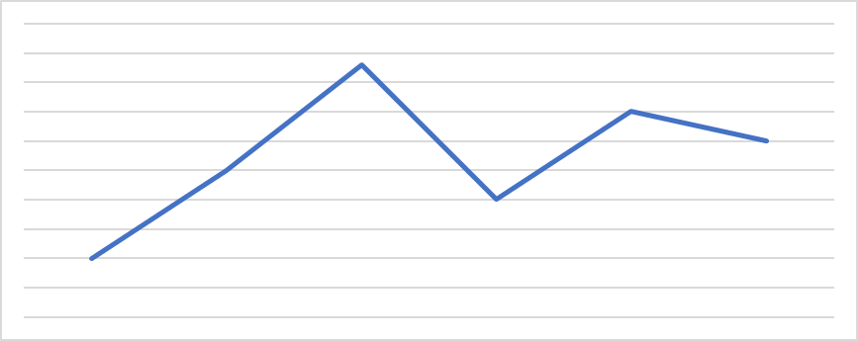
Figure 1. XXX
3 Analysis………………
3.1 Comparison………………….
Based on the actual data……………
4 Conclusion
Based on the actual data of urbanization level in Shandong province, Development Model, ………
References
[1]Shen, L. Y., Drew, D., and Zhang, Z. H. (1999). Optimal bid model for price-time biparameter construction contracts, Journal of Construction Engineering and Management, 125(3), 204-209.
[2]Shen, L. Y., Lee, K. H., and Zhang, Z. H. (1996). Application of BOT system for infrastructure projects in China, Journal of Construction Engineering and Management, 122(4), 319-323.
长摘要格式说明 (In Chinese)
1. 全文用A4 大小,字数800-1500；Times New Roman字体，无页码；不多于2页；
2. 大标题：三号加粗，居中，24磅行距；
3. 作者：小四加粗，居中，段前15磅，段后15磅；
4. 摘要，关键词：五号，单行倍距，Abstract和 Keywords加粗；
5. 摘要后加入分页符；
6. 作者简介放入首页页脚，字体为小五，单行倍距；
7. 一级标题：四号加粗，段前0.5行，段后0.5行；
8. 二级标题：小四加粗，段前0.5行，段后0.5行。若与一级标题相连，则段前0行，段后0.5行；
9. 三级标题：五号加粗；
10. 正文：五号，单行倍距。首段左对齐，其他段前空四格；
11. 参考文献：五号，悬挂缩进2字符，段间距为固定值14磅；
12. 表格标题：小五加粗，左对齐，段前0.5行，段后0行；
13. 表格内字体：小五；
14. 表格后若是段落，则段前0.5行，左对齐；
15. 页边距：普通 上2.54厘米，下2.54厘米，左和右为3.18厘米。

Format of extended abstracts (In English)
1. Use A4 page set-up, word number limit: 800-1500, only Times New Roman font should be used, and no page number should be printed. The extended abstract is no more than 2 pages.
2. Headline: the title should be in 16pt, bold, center the title, in 24pt column.
3. Author: 12pt, bold, center the author’s name, start and after each paragraph, with 15pt paragraph spacing.
4. The abstract and keywords: 10.5pt, in single column, word “Abstract” and “Keywords” in bold.
5. After abstracts, the page break should be inserted.
6. The author’s information should be in the footer section of home/front page, 9pt, single column.
7. The first class heading: 14pt bold, start and after each paragraph, with half column paragraph spacing.
8. The second class heading: 12pt, bold, start and after each paragraph, with half column paragraph spacing; if there has no interval with upper class, remove half column space above the current paragraph.
9. The third class heading: 10.5pt, bold.
10. Body text: 10.5pt, single column. Start each paragraph, except the first (left-justified), with 4-character indentations.
11. References: 10.5pt, with 2-character indentations in 14 pt paragraph spacing.
12. Table title: 9pt, bold, left-justified, start each title with half column paragraph spacing, after each title with zero paragraph spacing.
13. Fonts in tables: 9pt font.
14. Paragraph followed the table should be in half column paragraph spacing before with no indent.
15. Margins: Use A4 page set-up and make all margins as (top, bottom) 25.4 mm and (left, right) 31.8mm wide respectively.
Template for extended abstract
Awarding Construction Contracts on Multicriteria Basis in China
Liyin Shen*, Derek Drew, Qiping Shen
Abstract: China’s entry to the World Trade Organization (WTO) will allow both domestic and overseas construction firms to compete under the same market conditions. This development will lead to a more rigorous participation from overseas construction professionals in the Chinese construction market…………………
Keywords: China; Construction industry; Contracts; Competition.

Main Body Text: including a concise review of literature, methodology, findings, discussion, and summary sections. The number of words should be between 800 and 1500, and the number of pages is no more than 2.

* Liyin Shen Corresponding author, Department of ………, ………University, China E-mail: …………..@......com
Derek Drew School of …………….., …. ………… University, China 3 Qiping Shen School of …………….., …. ………… University, China

